

**Image degradation tool for synthetic dataset**

User Manual

# **Table of Contents**

1. ***Introduction***

1.1 Overview

1.2 Purpose of the Document

1. ***System/Application Description***

2.1 Key Features

2.2 User Access Mode

1. ***Installation and Setup***

3.1 MATLAB Installation

3.2 App Files

3.3 Launch MATLAB

3.4 Open the App

1. ***User Interface Overview***

4.1 Sections and Parameters

1. ***Operating Instructions***

5.1 Launch the App

5.2 Select source and destination options

5.3 Tick all checkbox

5.4 Tick preset checkbox in CCM matrix panel

5.5 Execute

1. ***Cautions &Warnings***

6.1 General Cautions

6.2 Specific Warnings

1. ***Troubleshooting***

7.1 Unexpected Output

7.2Slow Performance

7.3Error Messages

1. ***Best Practices***

8.1 Start Simple

8.2 Save Configurations

8.3Documentation

**1. Introduction**

**1.1 Overview**

The image degradation tool is a versatile tool designed to automate the creation of degraded image dataset. These datasets are essential for developing, testing, and benchmarking computer vision models, especially when real-world image datasets are difficult or expensive to obtain.

**1.2 Purpose of the Document**

This document serves as the User Manual for the image degradation tool. The purpose is to guide users through the initial setup, configuration, and operation of the system. The manual provides comprehensive instructions for generating degraded image datasets with varying characteristics, which are crucial for testing and comparing different computer vision models and approaches.

**2.** **System/Application Description**

The image degradation tool is equipped with the following key features:

**2.1 Key Features**

Customizable Image degradation: Users can choose various characteristics such as Modulation Transfer function and type of noise.

* Scalability: degrade large volumes of images quickly and efficiently.
* Integration Capabilities: Compatible with major machine learning frameworks for seamless model training and evaluation.
* User-Friendly Interface: Intuitive graphical user interface (GUI) for easy interaction and control.

**2.2 User Access Mode**

Graphical User Interface (GUI): The primary mode of interaction is through a MATLAB based GUI, which allows users to configure settings, initiate image degradation processes, and manage datasets.

**3.** **Installation and Setup**

**3.1 MATLAB Installation**

Ensure that MATLAB is installed on your computer. The app should be compatible with most recent versions of MATLAB.

**3.2 App Files**

Obtain the app files from your source and ensure they are placed in an accessible directory.

**3.3 Launch MATLAB**

Open MATLAB and navigate to the directory containing the app files.

**3.4 Open the App**

Run the script to launch the Image degradation tool. This can typically be done by typing the script name in the command window.

**4. User Interface Overview**

The user interface is divided into several sections, each corresponding to different noise and degradation settings. Below is a detailed description of each section and its parameters.

The following image illustrates the user interface:

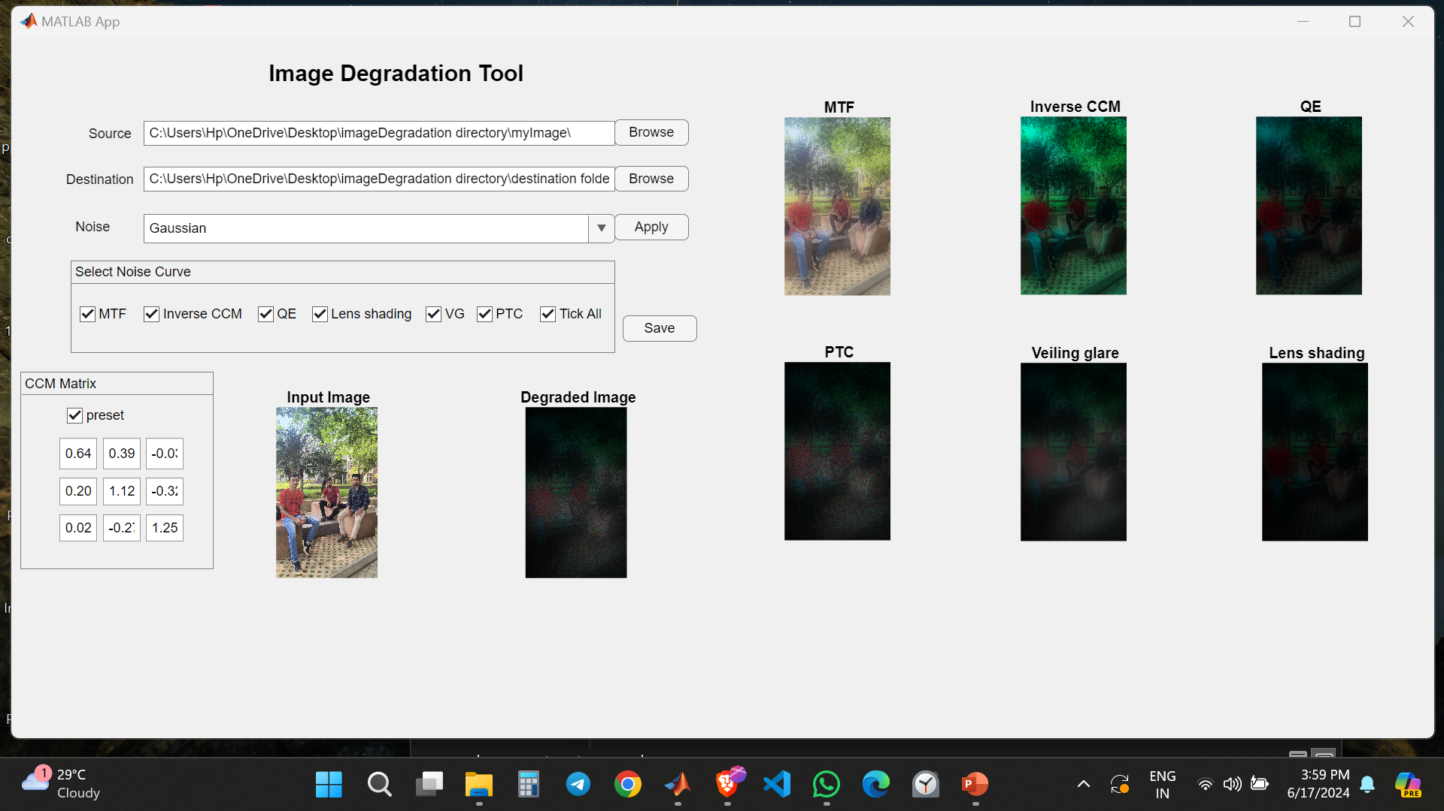

**4.1 Sections and Parameters**

General Options:

* **Source**: A section to define our source directory where the original undegraded images exist.
* **Destination**: A section to define our destination directory where the degraded images will be stored after processing.
* **Noise:** A section to add a noise to the original image before entering into the degradation pipeline.
* **Apply button:** To apply the chosen noise to the image.

Note: Click the apply button of the noise section before hitting the save button of the degradation pipeline.

1. Select Noise Curve panel:

* Checkbox (MTF): Enable or disable the application of modulation transfer function(MTF).
* Checkbox (Inverse CCM): Enable or disable the inverse CCM.
* Checkbox (Quantum Efficiency[QE]): Enable or disable the quantum efficiency.
* Checkbox (Lens Shading): Enable or disable the lens shading settings.
* Checkbox (Vailing Glare): Enable or disable the vailing glare settings.
* Checkbox (PTC): Enable or disable the photon transfer curve settings.

1. CCM matrix panel:

* Checkbox (Preset): To enable preset CCM(3x3) values for applying inverse CCM.
* There is also flexibility to provide your own CCM matrix by changing the values in the edit fields.

Note: Click the preset or provide your own values in the edit fields before clicking the save button otherwise it will take the (3x3) zeros matrix.

1. Plots:

* MTF: Shows the plot of image degraded with MTF.
* Inverse CCM: shows the plot of image further degraded with inverse CCM.
* QE: shows the plot of image further degraded with quantum efficiency.
* Lens Shading: shows the plot of image further degraded with lens shading with center of the bright spot shifted by an offset of 90 pixels to the right on x-axis.
* Vailing Glare: shows the plot of image further degraded with vailing glare with glare intensity of 2.5.
* PTC: shows the plot of image further degraded with photon transfer curve.

**5.** **Operating Instructions**

**5.1 Launch the App**

* Launch MATLAB on your computer.
* In the command window, type ‘appdesigner’ to launch the GUI.

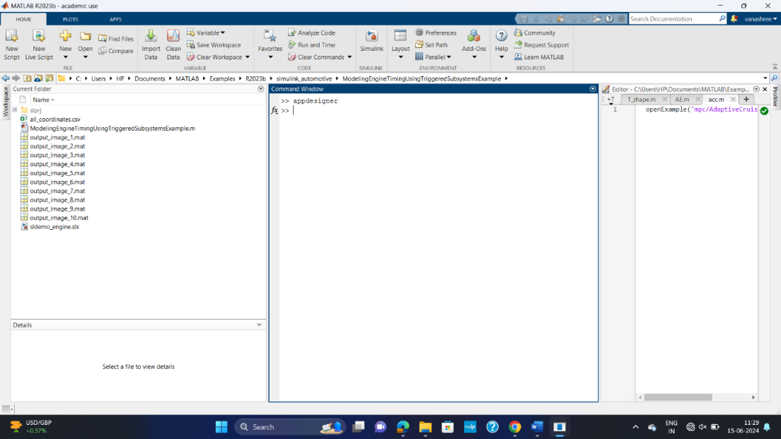

* In Designer view, click "Open" to launch the appropriate app for accessing the required GUI.

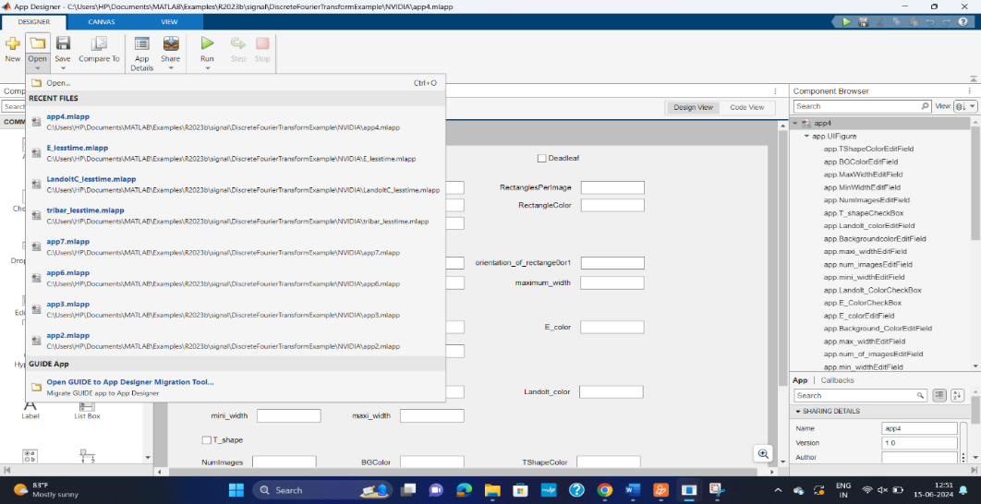

* Now that the app is open, click on "Run" to proceed.

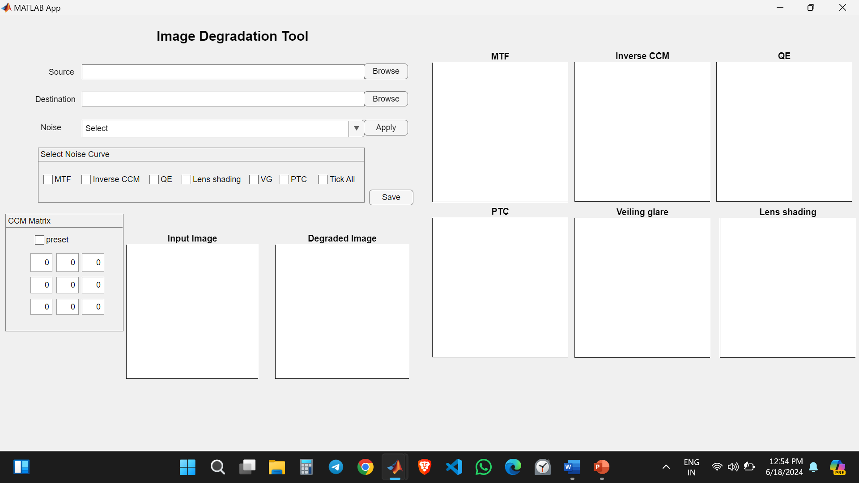

**5.2** **Select source and destination options**

* Select the source and destination of where the images will be taken from and saved after degradation.



* Select the type of noise you want to apply for the image and click apply button.

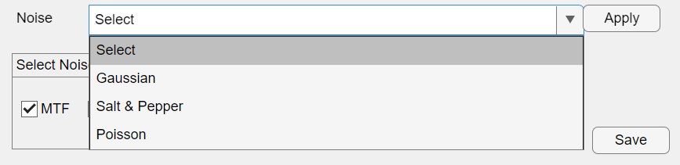

Note: Click the apply button of the noise section before hitting the save button of the degradation pipeline.

**5.3 Tick all checkbox.**

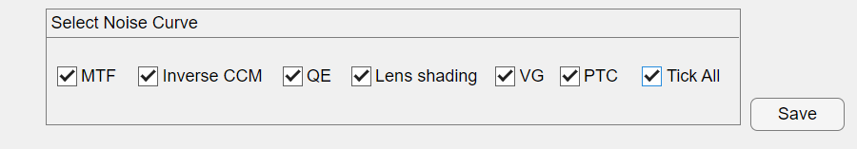

Use tick all check box to select all the checkboxes that apply in degradation pipeline.

**5.4 Tick preset checkbox in CCM matrix panel**

Click the preset check box to apply the existing matrix values, otherwise you have to provide your CCM values to in the edit field.

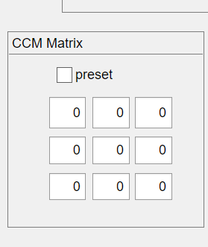 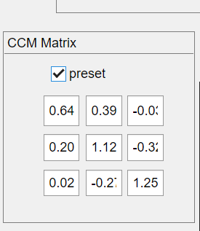

Note: Click the preset or provide your own values in the edit fields before clicking the save button otherwise it will take the (3x3) zeros matrix.

**5.5 Execute**

Click the save button if you followed all the previous process to degrade the images.

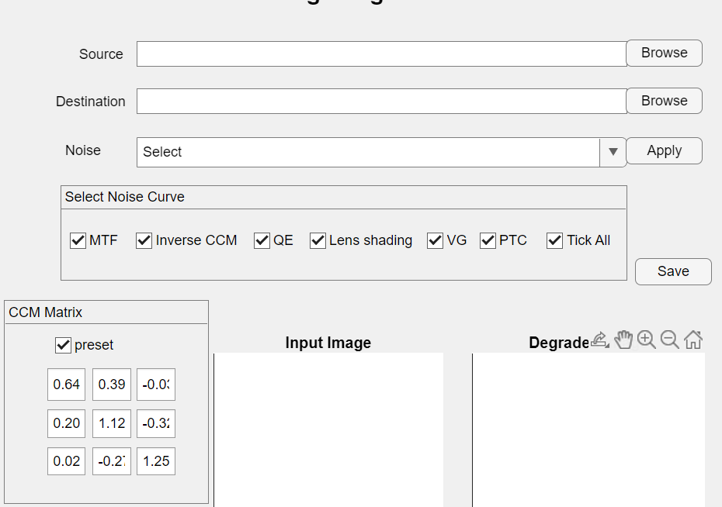

Generated degraded image:

This is the output from the GUI after following all the procedure.

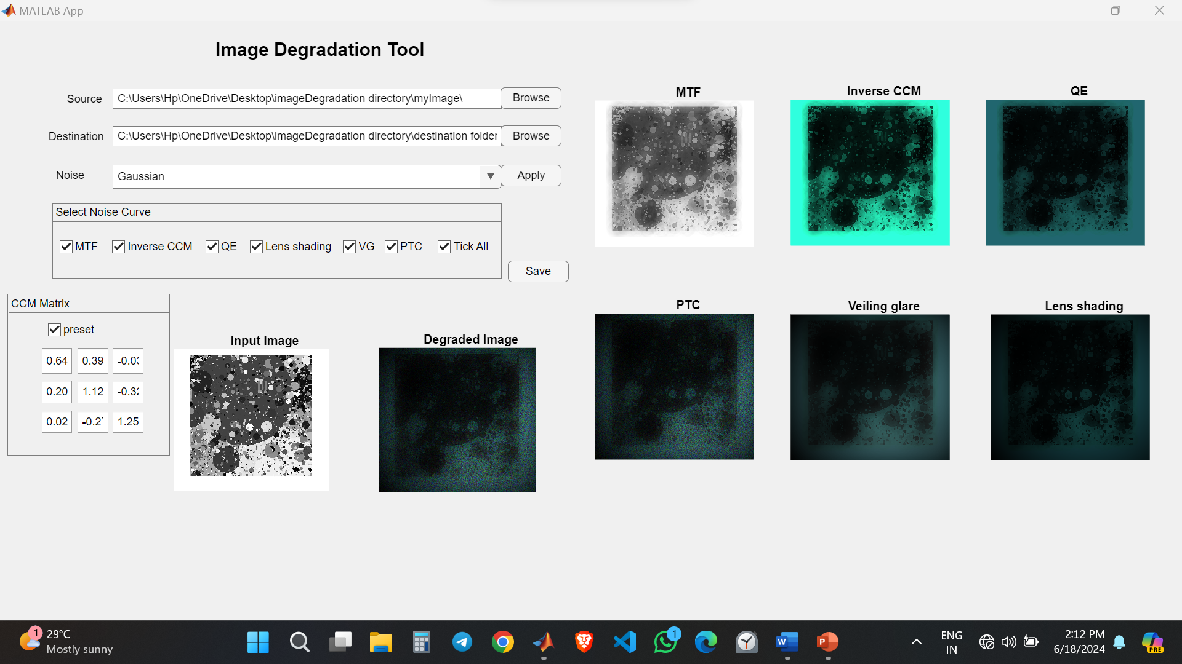

MTF Example Image:

Here is output after applying MTF.

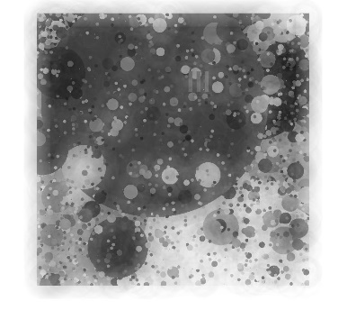

Inverse CCM Example Image:

Here is the output after applying Inverse CCM.

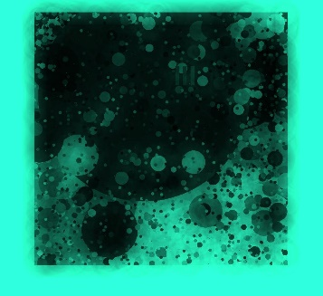

Quantum Efficiency(QE) Example Image:

Similarly for quantum efficiency.



Lens shading Example Image:

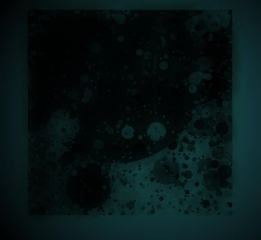

Vailing Glare Example Image:

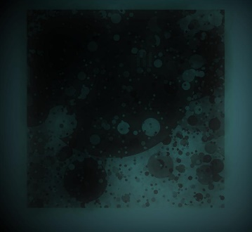

PTC Example Image:

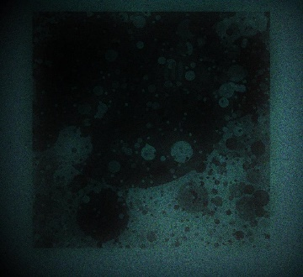

**6.** **Cautions & Warnings**

**6.1 General Cautions**

1. Click the preset or provide your own values in the edit fields before clicking the save button otherwise it will take the (3x3) zeros matrix.

2. Click the apply button of the noise section before hitting the save button of the degradation pipeline.

3. Unique Colors: Ensure that colors for different elements (e.g., background, shapes) are distinguishable to avoid visual confusion in the generated images.

**6.2 Specific Warnings**

1.Empty Fields: Leaving required fields empty result in errors or incomplete processing.

2. File Permissions: Ensure you have the necessary file permissions if the app involves reading from or writing to files.

**7.** **Troubleshooting**

**7.1 Unexpected Output**

Double-check all input parameters for types or logical errors.

**7.2 Slow Performance**

For slow performance issues, consider running the app on a more powerful machine or optimizing your parameters to reduce computational load.

**7.3 Error Messages**

Pay attention to MATLAB error messages for clues on how to fix issues. Common errors can often be traced back to incorrect input formats or unsupported parameter values.

**8.** **Best Practices**

**8.1 Start Simple**

Begin with simpler configurations to understand the basic functionality of the app.

**8.2 Documentation**

By following this manual, you can effectively use the image degradation tool to generate degraded images with the desired properties while minimizing potential issues and maximizing efficiency.